**ALINYIIKIRA JUNIOR SCHOOL, NAKWERO**

**BEGINNING OF TERM 3 ASSESSMENT 2024**

**MIDDLE CLASS**

**LAERNING AREA 4 (MATHEMATIAL CONCEPTS)**

Name: _________________________________________________

1. **Match the same sets.**

 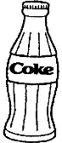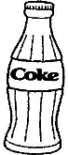

 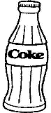

 

 

 

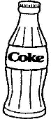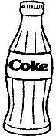 

 

 

1. **Copy.**

16 17 18 19 20

16

21 22 23 24 25

1. **Count and write.**

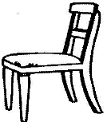



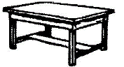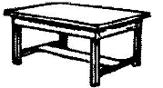











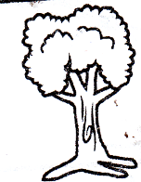

 =

**1, 2, 3, 4, 5, 6, 7, 8, 9, 10**

1. **Copy and draw.**

|  |  |  |
| --- | --- | --- |
|  |  |  |
| C | tr | r |
|  |  |  |
|  |  |  |
| sq | c | o |
|  |  |  |

1. **Complete these:**

 A set of 2 cups.

 A set of _________ boxes.



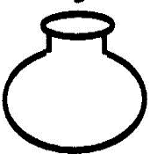 A set of __________ pots.



 A set of __________ bags.



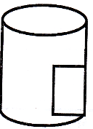 A set of __________ tins.

1. **Fill in the missing numbers.**

I, ______, _______, 4, 5, ______, 7, ______, 9, ______, 11, ______, 13, ______, 15.

1. **Circle the big picture.**

